INTERNATIONAL STANDARD ISO 17123-4
Optics and optical instruments – Field procedures for testing geodetic and surveying instruments
Part 4: Electro-optical distance meters (EDM instruments)
Full test procedure
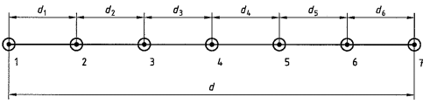  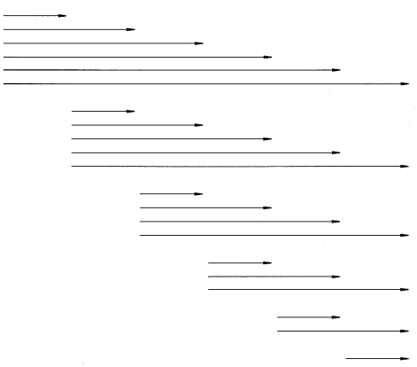 |  |  | Cálculo das distâncias entre o aparelho e os prismas, dependendo da unidade de comprimento (unit length) U do EDM  d₀=600 m; λ=____; β₀=(d₀ -6.5*λ)/15=____; β=int(β₀)=____; γ=λ/72=____  d₁=λ+β+3γ=______________ d₂=λ+3β+7γ=______________  d₃=λ+5β+11γ=______________ d₄=λ+4β+9γ=______________  d₅=λ+2β+5γ=_____________ d₆=λ+γ=______________  d=6λ+15β+36γ=______________  Data: ____ /_____ /____  Hora: _______________  Grupo: ______________  Operador: ___________  Aparelho: ____________  Condições atmosféricas: _________________________________
d_{1,2}= | d_{1,3}= | d_{1,4}= |  | d_{1,5}= | d_{1,6}= | d_{1,7}=
 | d_{2,3}= | d_{2,4}= |  | d_{2,5}= | d_{2,6}= | d_{2,7}=
 |  | d_{3,4}= |  | d_{3,5}= | d_{3,6}= | d_{3,7}=
 |  |  |  | d_{4,5}= | d_{4,6}= | d_{4,7}=
 |  |  |  |  | d_{5,6}= | d_{5,7}=
 |  |  |  |  |  | d_{6,7}=

a₄= d_{1,5}+ d_{2,6}+ d_{3,7}- d_{1,4}- d_{2,5}- d_{3,6}- d_{4,7}= |  |  | b₁=(d_{1,2}+d_{1,3}+d_{1,4}+d_{1,5}+d_{1,6}+d_{1,7})/7=
a₅= d_{1,6}+ d_{2,7}- d_{1,3}- d_{2,4}- d_{3,5}- d_{4,6}-d_{5,7}= |  |  | b₂=(d_{2,3}+d_{2,4}+d_{2,5}+d_{2,6}+d_{2,7}-d_{1,2})/7=
a₆= d_{1,7}- d_{1,2}- d_{2,3}- d_{3,4}- d_{4,5}-d_{5,6}-d_{6,7}= |  |  | b₃=(d_{3,4}+d_{3,5}+d_{3,6}+d_{3,7}-d_{1,3}-d_{2,3})/7=
 |  |  | b₄=(d_{4,5}+d_{4,6}+d_{4,7}-d_{1,4}-d_{2,4}-d_{3,4})/7=
 |  |  | b₅=(d_{5,6}+d_{5,7}-d_{1,5}-d_{2,5}-d_{3,5}-d_{4,5})/7=
 |  |  | b₆=(d_{6,7}-d_{1,6}-d_{2,6}-d_{3,6}-d_{4,6}-d_{5,6})/7=
δ=(a₄+3a₅+5a₆)/35= |  |  | b₇=(-d_{1,7}-d_{2,7}-d_{3,7}-d_{4,7}-d_{5,7}-d_{6,7})/7=

r_{1,2}= b₁-b₂-5δ/7-d_{1,2} | r_{1,3}= b₁-b₃-3δ/7-d_{1,3} | r_{1,4}= b₁-b₄-δ/7-d_{1,4} | r_{1,5}= b₁-b₅+δ/7-d_{1,5} | r_{1,6}= b₁-b₆+3δ/7-d_{1,6} | r_{1,7}= b₁-b₇+5δ/7-d_{1,7}
 | r_{2,3}=b₂-b₃-5δ/7-d_{2,3} | r_{2,4}=b₂-b₄-3δ/7-d_{2,4} | r_{2,5}=b₂-b₅- δ/7-d_{2,5} | r_{2,6}=b₂-b₆+ δ/7-d_{2,6} | r_{2,7}=b₂-b₇+3δ/7-d_{2,7}
 |  | r_{3,4}=b₃-b₄-5δ/7-d_{3,4} | r_{3,5}=b₃-b₅-3δ/7-d_{3,5} | r_{3,6}=b₃-b₆- δ/7-d_{3,6} | r_{3,7}=b₃-b₇+ δ/7-d_{3,7}
 |  |  | r_{4,5}=b₄-b₅-5δ/7-d_{4,5} | r_{4,6}=b₄-b₆-3δ/7-d_{4,6} | r_{4,7}=b₄-b₇- δ/7-d_{4,7}
 |  |  |  | r_{5,6}=b₅-b₆-5δ/7-d_{5,6} | r_{5,7}=b₅-b₇-3δ/7-d_{5,7}
 |  |  |  |  | r_{6,7}=b₆-b₇-5δ/7-d_{6,7}

$\sum{r^{2}}=r_{1,2}^{2}+r_{1,3}^{2}+r_{1,4}^{2}+r_{1,5}^{2}+r_{1,6}^{2}+r_{1,7}^{2}+r_{2,3}^{2}+r_{2,4}^{2}+r_{2,5}^{2}+r_{2,6}^{2}+r_{2,7}^{2}+r_{3,4}^{2}+r_{3,5}^{2}+_{3,6}^{2}+r_{3,7}^{2}+r_{4,5}^{2}+r_{4,6}^{2}+r_{4,7}^{2}+r_{5,6}^{2}+r_{5,7}^{2}+r_{6,7}^{2}=$
ν=n-u=21-7=14

