Inovação, Empreendedorismo e Transferência de Tecnologia

Doc. Responsável: Helena Vieira
Departamento: DEIO
Inserção no Plano Curricular: Mestrado em MICROBIOLOGIA IST/FCUL (1º ano, 1º sem, obrigatória)
Créditos/Horas de Contacto: 6ECTS; 30 horas T + 15 horas OT
Contacto: hmvieira@fc.ul.pt

EXECUTIVE SUMMARY & BUSINESS PLAN SUPPORT INFO

Typical structure examples

A Business plan may vary in its presentation but its main structural points are kept in all examples. It must include:
- executive summary
- The problem
- The solution
- Market & Customer segments & competition
- How you will implement it
- What do you need to implement it (operational and financial)

Next some examples are provided just as inspiration.

EXECUTIVE SUMMARY

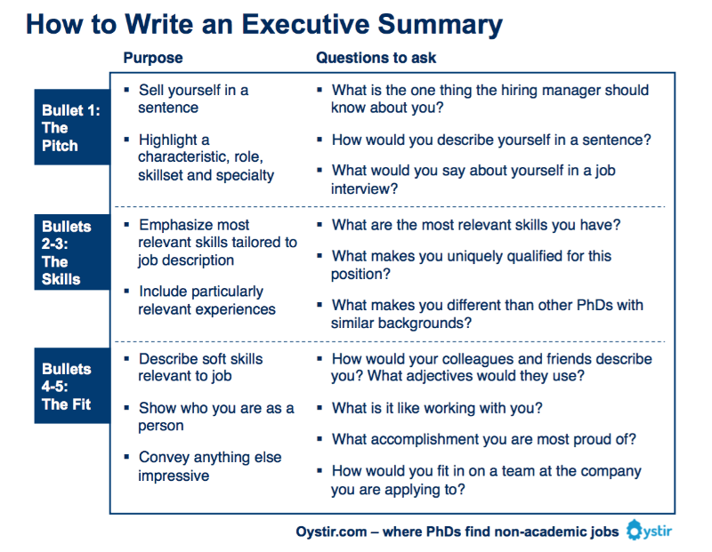

Example 1 – EXECUTIVE SUMMARY
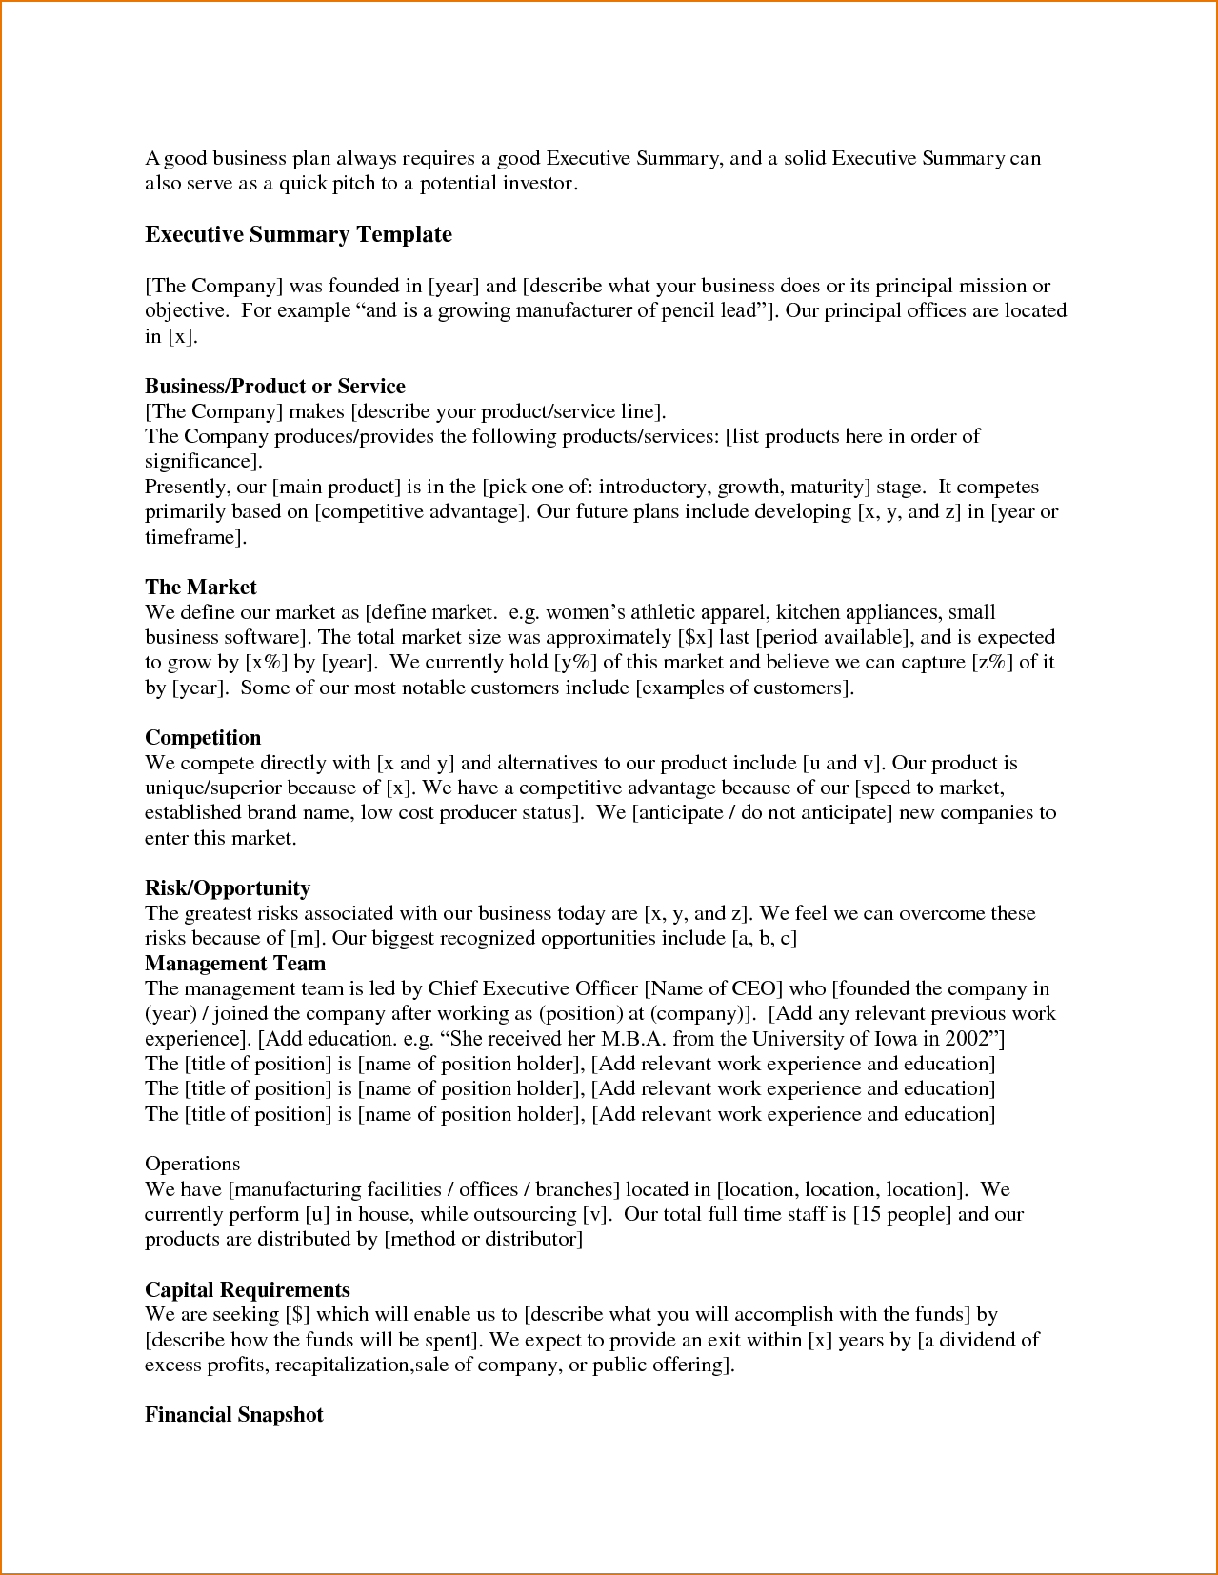

Example 2 – EXECUTIVE SUMMARY
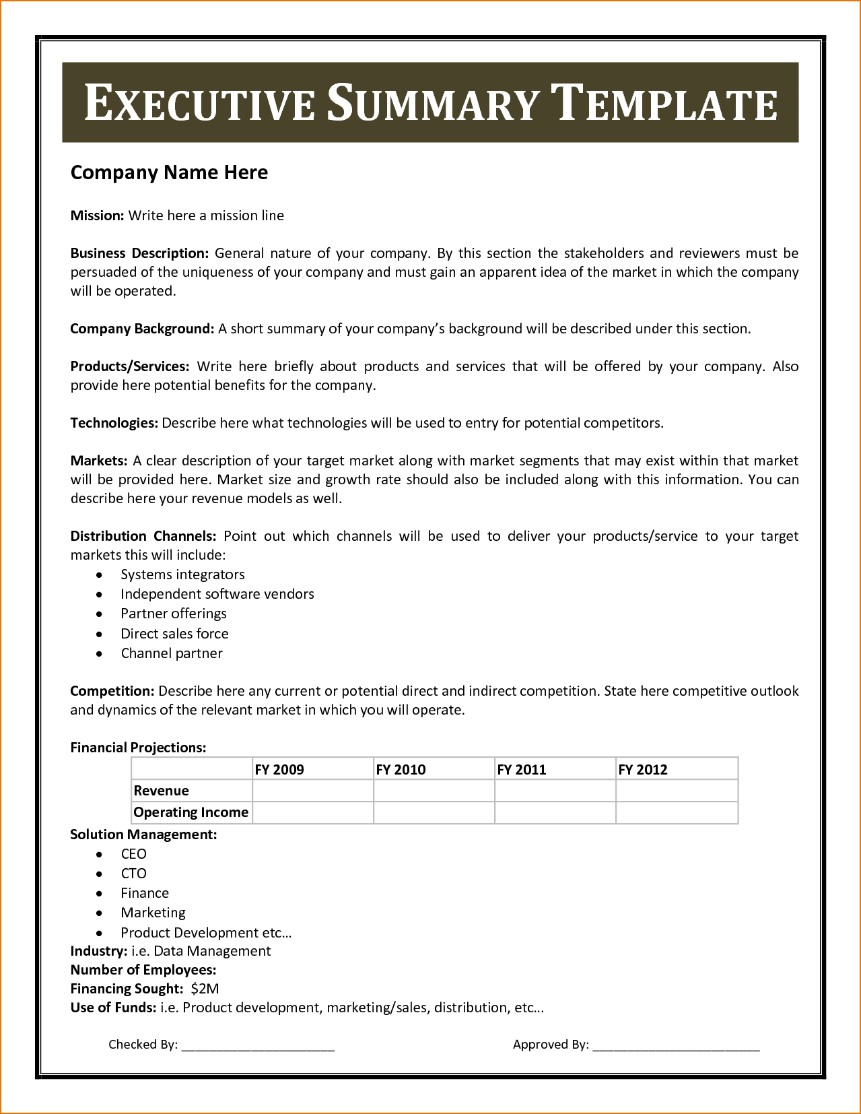

Exemple 3: EXECUTIVE SUMMARY

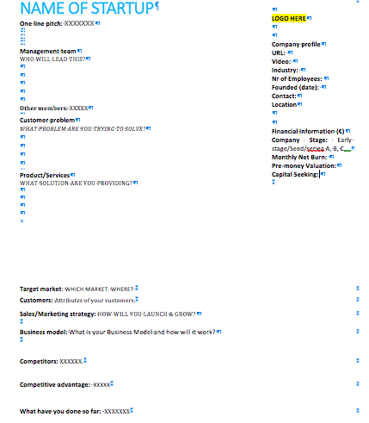

Example 1: Business Plan
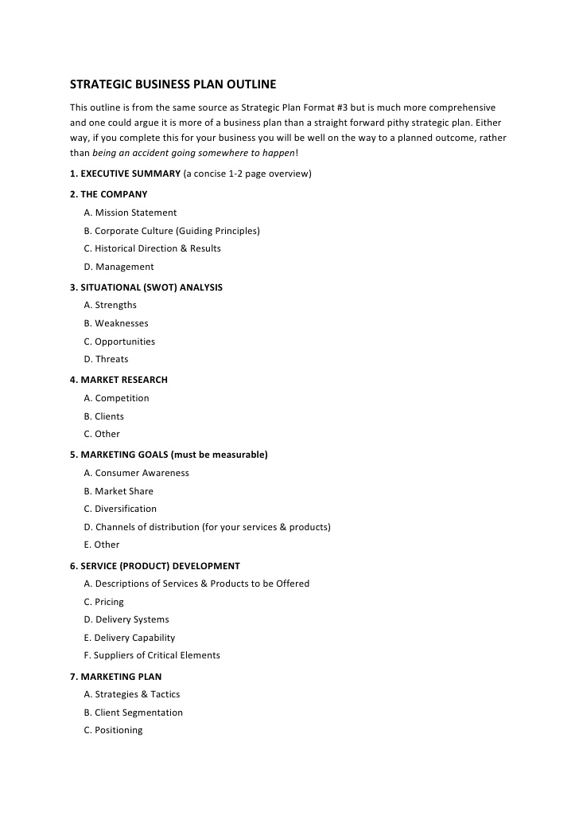

Example 2

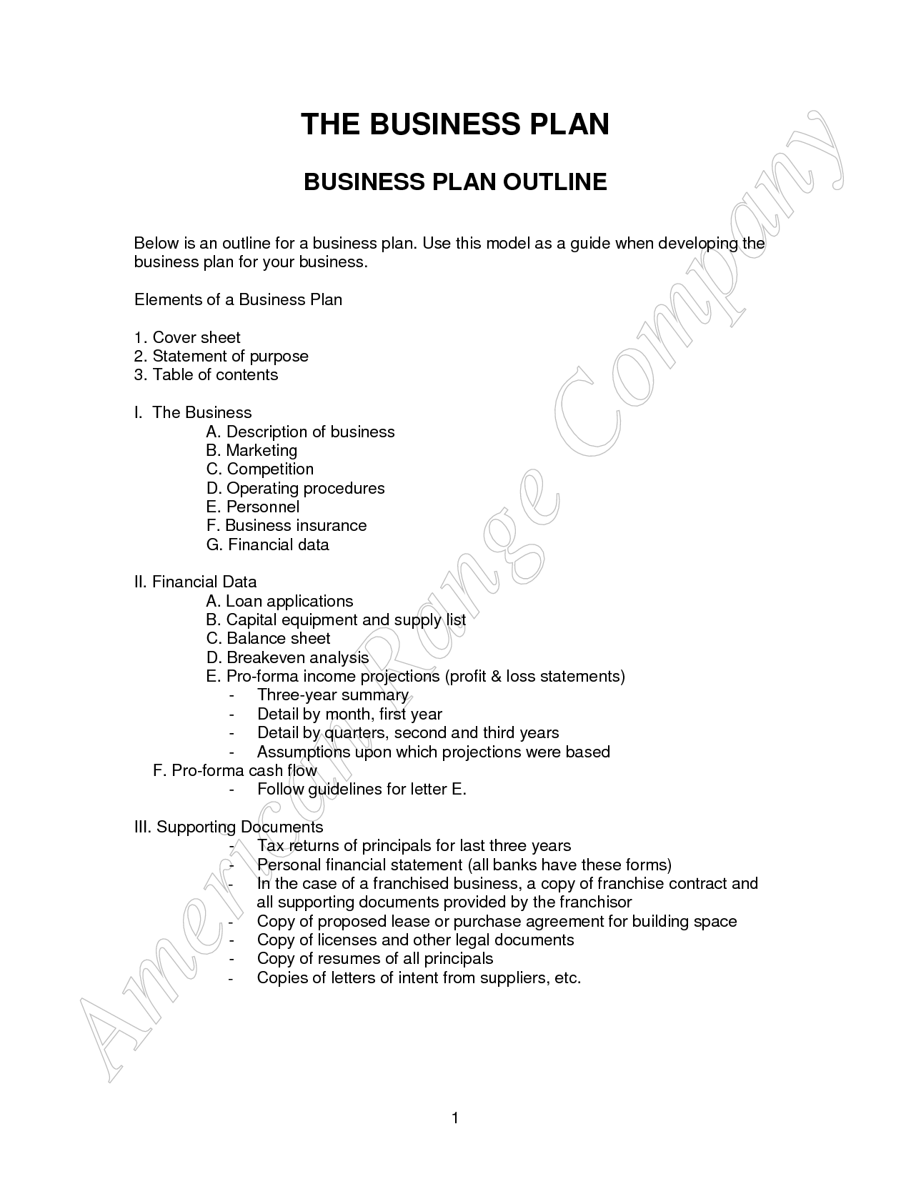

More information:
http://articles.bplans.com/a-standard-business-plan-outline/

