Digitizing Data

Each group will digitize their data from the field and from the laboratory. All data have a life cycle that can be described as follows:

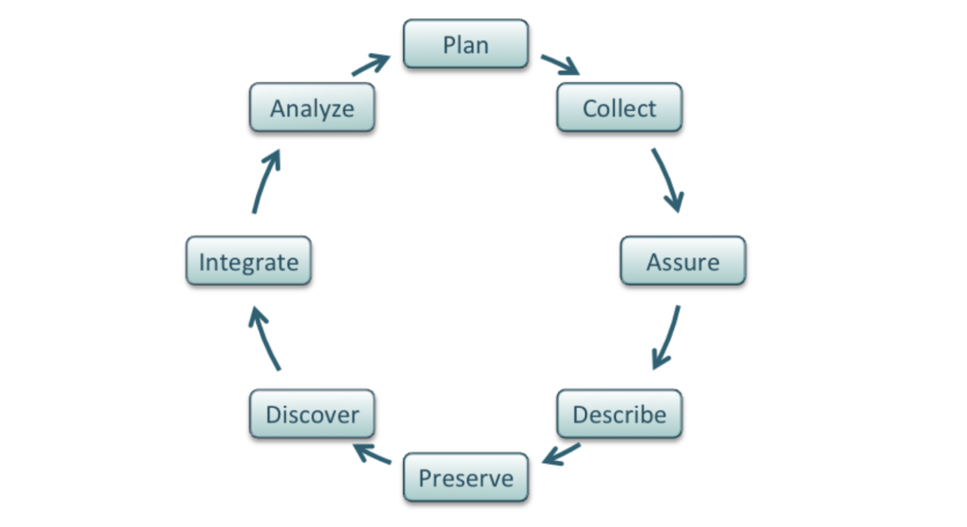
Figure 1. The data life cycle begins with planning and collecting the data, then assuring the quality of those data, describing the attributes of the data, and ultimately archiving them in a way that they can subsequently be discovered, integrated into other projects and analyzed to create new knowledge. (Strasser et al. 2012 from DataOne)

We are at the stage where we want to describe the data so that we can analyze it in the context of this project, as well as preserve it for the future. There are a number of components to best practices for describing data, including documenting:

- Why and how the data was collected.
- How the data is structured and how files relate to one another.
- Whether or not the data is complete.
- Who can access the data and how it can be used.
- How versions of the data are named and tracked over time.

We will build our files in a format that can easily be accessed (csv; comma separated values), which can be done in Google Sheets. Your group should consider and incorporate the following into your data files:

Name Your File:
https://dataoneorg.github.io/Education/bestpractices/assign-descriptive-file

Define the Key Parameters (e.g., sample #, species, leaf area):
https://dataoneorg.github.io/Education/bestpractices/define-the-parameters

Describe the Units of Measurement (e.g., m²):
https://dataoneorg.github.io/Education/bestpractices/describe-the-units

Create a (Second) Separate Data Dictionary Tab: https://dataoneorg.github.io/Education/bestpractices/create-a-data

Create a (Third) Separate Metadata Tab:
https://dataoneorg.github.io/Education/bestpractices/identify-and-use

Before beginning, you may wish to explore some of the data sets archived at DataDryad, which is a common and generally well-curated permanent repository for ecological data.

